To quickly access an application you frequently use, the icon can be pinned to the task bar or the Start Page, so it is always visible.

* Click on the Start Menu

Screen print showing the start menu icon made of 4 blue squares.

* Type in the name of the app you want to pin to the Start Page or Task Bar.

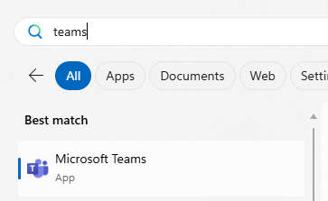

* Right click over the application

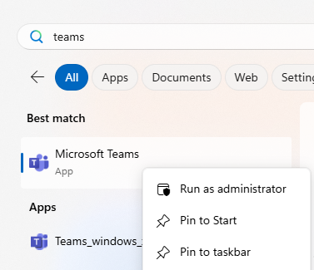

* Select either Pin to Start or Pin to taskbar.
* Any apps pinned to the taskbar will now be displayed on the taskbar permanently rather than only when open.

Screen print showing the pinned apps on the taskbar.

* Any apps pinned to Start will always be shown

